# Topic IoT Applications in Agriculture

Livestock Monitoring

User: Farmer

business types: Business to Business or Business to customer

budget : around 2k – 3.5k

Large farm owners can utilize wireless IoT applications to collect data regarding the location, well-being, and health of their cattle. This information helps them in identifying animals that are sick so they can be separated from the herd, thereby preventing the spread of disease. It also lowers labor costs as ranchers can locate their cattle with the help of IoT based sensors.

JMB North America is an organization that offers cow monitoring solutions to cattle producers. One of the solutions helps the cattle owners observe cows that are pregnant and about to give birth. From the heifer,

a sensor powered by battery is expelled when its water breaks. This sends an information to the herd manager or the rancher. In the time that is spent with heifers that are giving birth, the sensor enables farmers to be more focused.

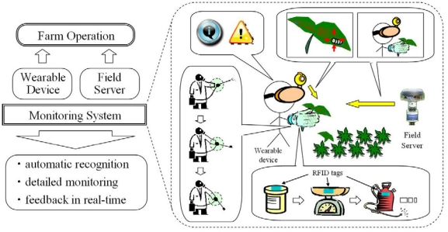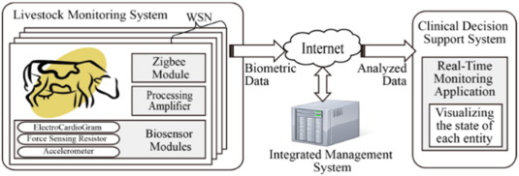

(example back- ends)

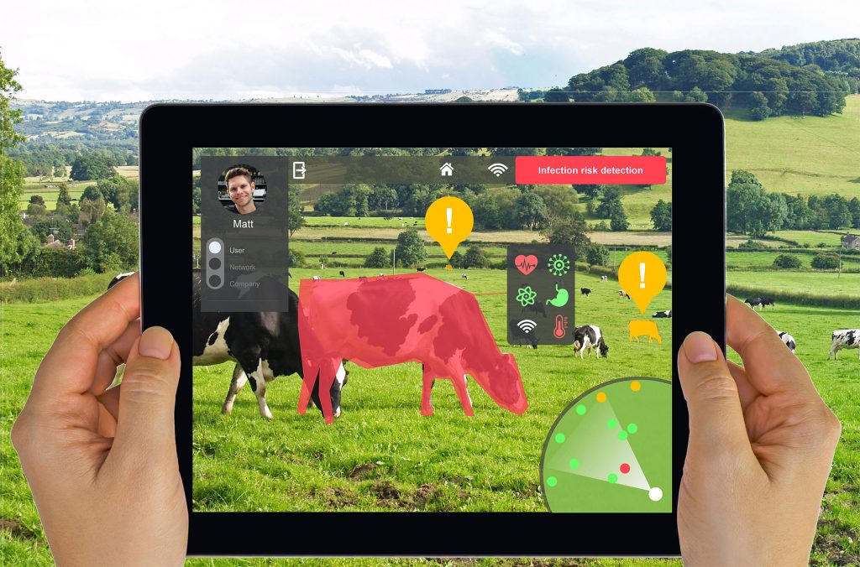

(example UI )

## Conclusion

Thus, the IoT agricultural applications are making it possible for ranchers and farmers to collect meaningful data. Large landowners and small farmers must understand the potential of IoT market for agriculture by installing smart technologies to increase competitiveness and sustainability in their productions. The demand for growing population can be successfully met if the ranchers as well as small farmers implement agricultural IoT solutions in a successful manner.